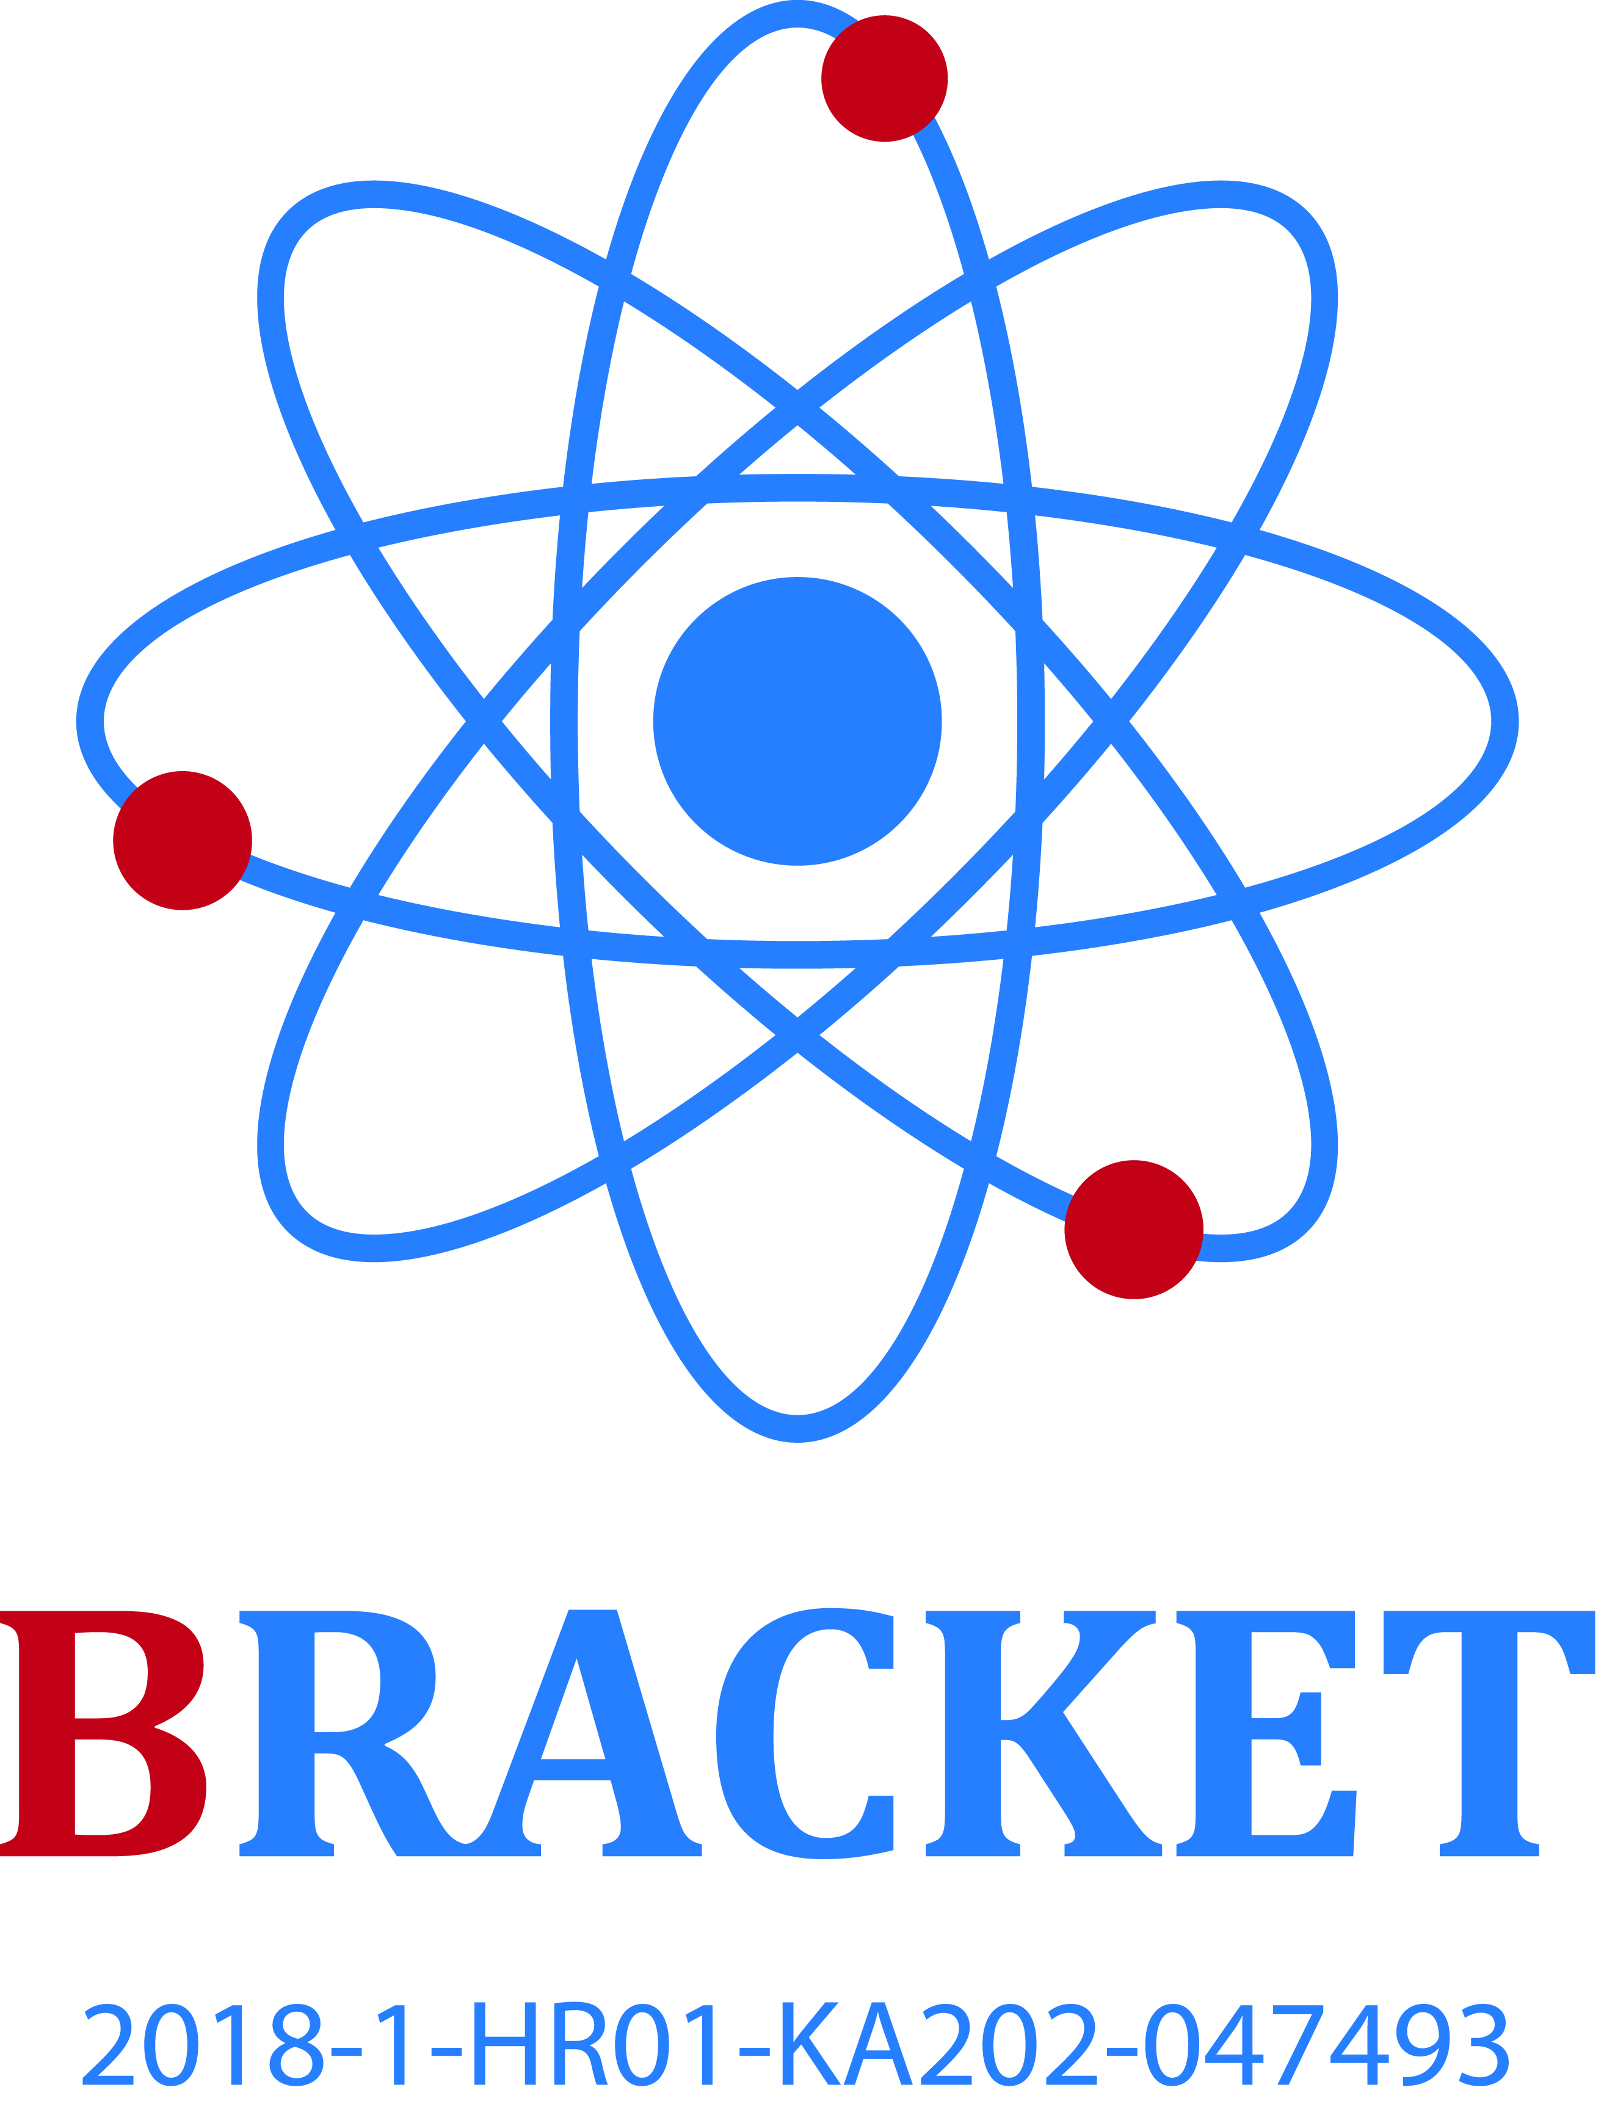
PROJECT

NEWSLETTER
ISSUE 6 - 04/2021

Boosting a novel and innovative tRAining approaCh of Key Enabling Technologies

BRACKET INFO
The BRACKET project is a study of the representation of new technologies (nanotechnology, biotechnology and advanced materials) in Vocational Education and Training (VET). In the scope of the project, the situation analysis in the project partner countries was carried out, as well as the preparation and implementation of a new training program in the field of key advanced technologies and a joint platform for cooperation containing all educational content developed through the project.
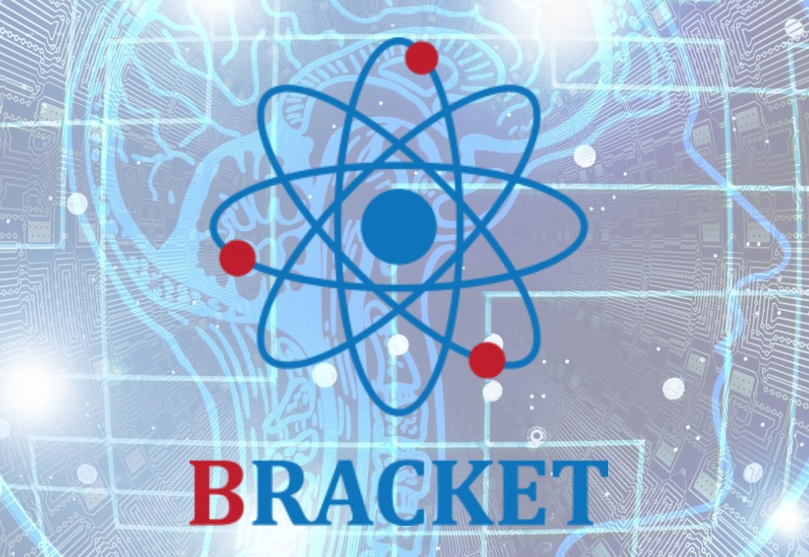
November 1, 2018 - April 30, 2021
IN THIS ISSUE:
BRACKET info………….………….. 1
What has been done ………….2
BRACKET final conferences………….……..….…..4
Tap here to add a caption

WHAT HAS BEEN DONE SO FAR
LAST PROJECT ONLINE PARTNER MEETING
On 13th April 2021 the Consortium of BRACKET held the 6th project partner meeting which was scheduled to take place in Riga, Latvia, but due to Covid-19, it was held online. This was the last meeting of the BRACKET project and the time to look back to the moments we shared together during two years.
The purpose of this meeting was to summarize all the activities completed within BRACKET project and to agree on the last steps and deadlines in order to successfully finalize the project. Also, project partners presented e-learning pilot testing activities completed in each country, to share the results and feedback received from pilot testers.

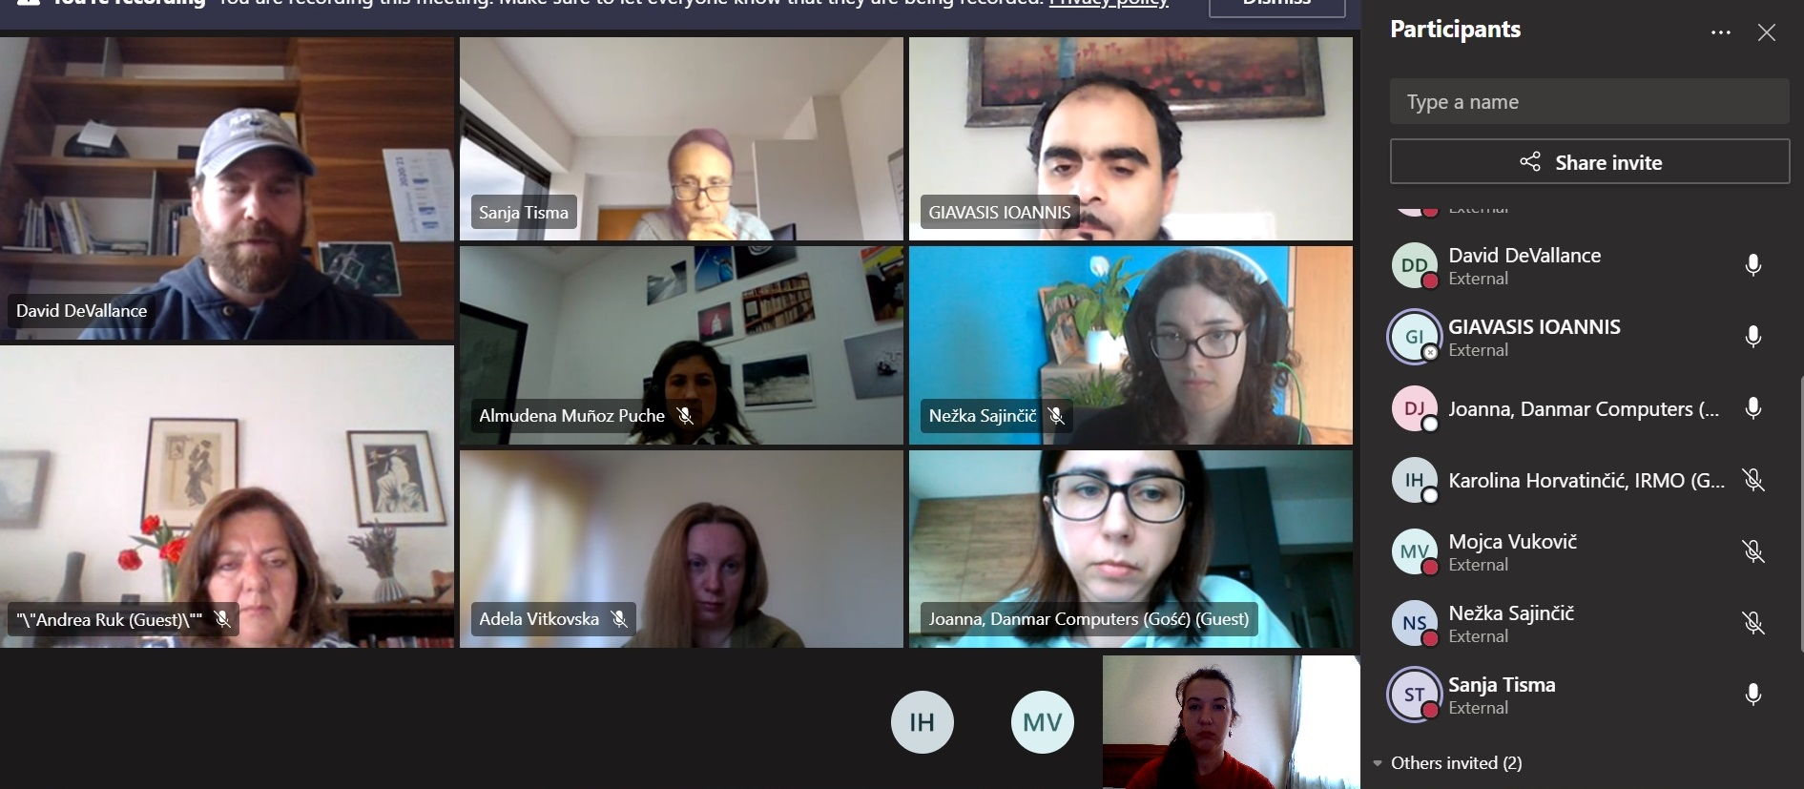

REAL VERIFICATION OF THE BRACKET TRAINING COURSE
Since the beginning of March all the BRACKET project partners in their countries have been leading Real Verification activities of the BRACKET training course. These activities served to field-test the actual effectiveness and usability of the online training course and the BRACKET Platform. In total during Real Verification activity 84 people registered on the BRACKET e-learning platform and from them 59 people filled out the evaluation questionnaires. 50 of them (85%) belonged to the category students/employees and 9 of them (15%) to the category teachers/managers.
In general, the feedback received from participants of REAL Verification activity were very positive. The BRACKET site is designed in a very accessible way, good presentations for studies, meaningful and clear. There is a way to share information and encourage discussion between students (exchange forum) as well as a rich source of additional learning resources in each lesson (bibliography) which contributes to more effective student learning.

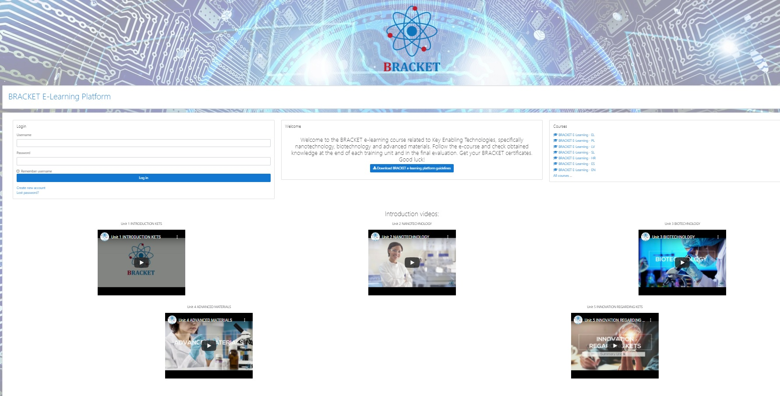

BRACKET E-LEARNING COURSE
After finishing Real Verification activities, BRACKET Consortium offers a freely available BRACKET e-learning course related to Key Enabling Technologies, specifically nanotechnology, biotechnology and advanced materials. The training course is designed for VET students, workers and managers of industries, experts in education and research centres encouraging to focus their profession in technological innovation and research fields.
When you end the BRACKET E-Learning Platform you will have the possibility to upskill in different units (KETs introduction, Nanotechnology, Biotechnology, Advanced Materials and Innovation regarding KETs), being independent from each other and avoiding redundancies among them.
The BRACKET online training is available for free after registration. This training is available in seven different languages: English, Croatian, Spanish, Slovenian, Greek, Polish and Latvian.

You can have access to the BRACKET training course through the following link: https://bracket.erasmus.site/mooc/

BRACKET FINAL CONFERENCES
Multiplier events organized by all the partners aim to showcase all results and outcomes developed within BRACKET beyond the partnership: Analysis, Didactic contents, the collaborative platform, lessons learned and experienced acquired. These events at national level, apart from disseminating the wide range of intellectual outputs produced within the project, will also improve the understanding of their use and the presentation of all their potentialities for the purpose of the enhancement of skills and knowledge on Key Enabling Technologies in the field of Vocational Education and Training.
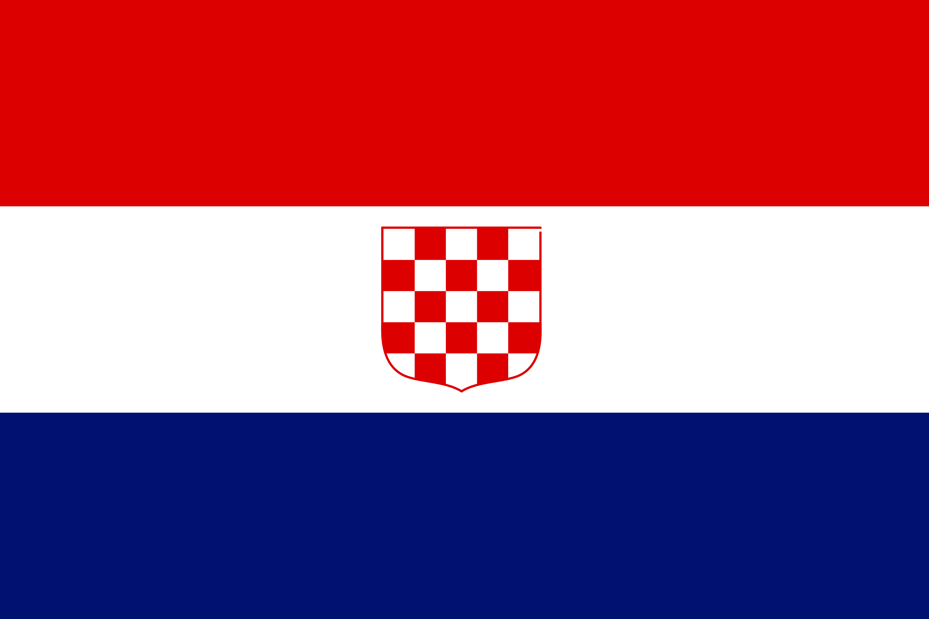
GREECE

SLOVENIA
20th April 2021
Virtual Workshop
Organizer: INNORENEW COE

POLAND
LATVIA
27th April and 28th April
Two face-to-face seminars
Organizer: BIEDRĪBA EUROFORTIS
For more information contact:
laura.vavilova@eurofortis.lv

SPAIN
CROATIA
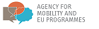
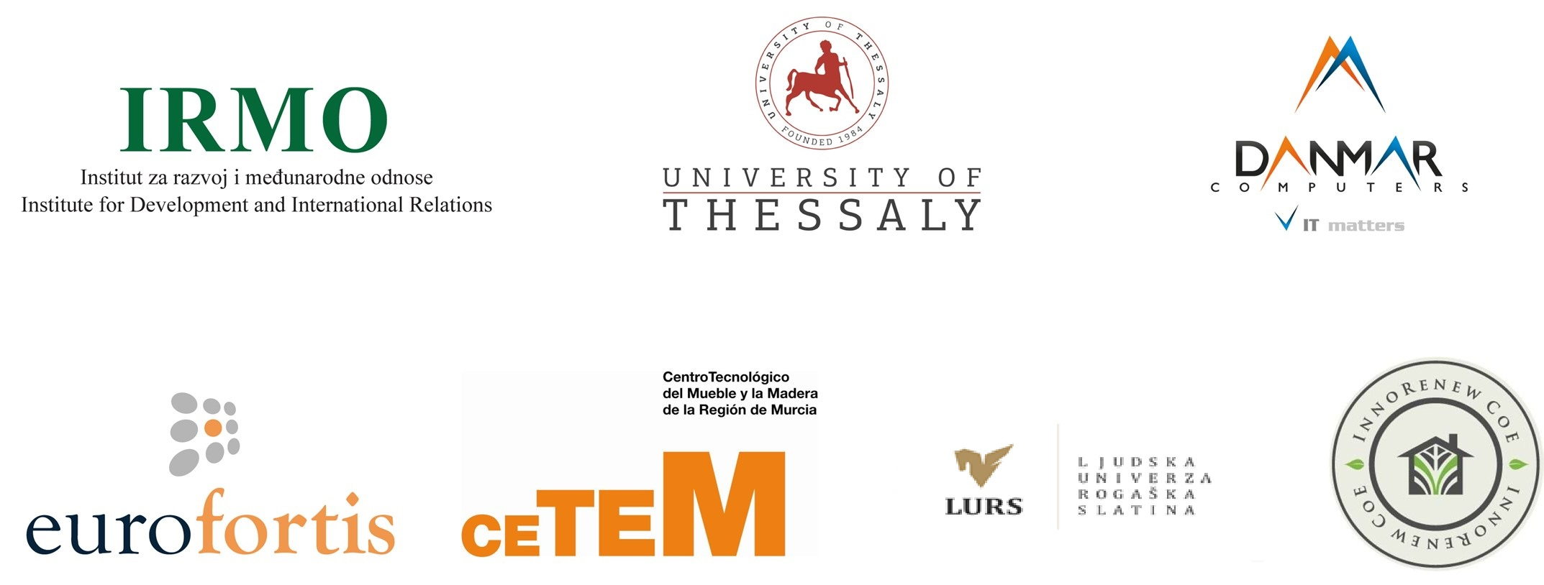

The publication reflects the views of the authors, and the Commission cannot be held responsible for any use which may be made of the information contained therein.

