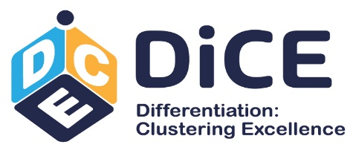

ON-LINE DiCE REGIONAL ASSEMBLY: CROATIA
Differentiated Integration in the European Union: Impacts for the regional and local governments in Croatia
WEDNESDAY, 1 JUNE 2022 10:00 - 12:00
DiCE Regional Assemblies are small expert workshops gathering representatives from the regional and local governments of 7 EU member states, which aim to discuss the different policy scenarios and recommendations that have been developed by the DiCE project cluster and to reflect on their potential implications for policy-making at the sub-national level of governance. The DiCE Regional Assembly in Croatia is organised by the Trans European Policy Studies Association (TEPSA) in cooperation with its member institute from Croatia the Institute for Development and International Relations (IRMO) Zagreb.
Within the online workshop TEPSA researchers will present main findings of their projects which address the following issues:
• How these projects define differentiation?
• What were the main project conclusions?
• What are scenarios for future EU differentiation?
• What are the key policy recommendations?

During discussion the local moderator will lead an open discussion with regional representatives covering the following aspects:

• Understanding of differentiated integration
• Impact of differentiated integration on the regions
• Desirability of differentiated integration scenarios (benefits and risks)
• Impact of differentiated integration

Apply to participate at: https://forms.gle/XksttWre2pAWibWdA

PROGRAME

10:00 – 10:15 Welcome remarks
-Hrvoje Butković, IRMO, Zagreb

10:15 – 10:45 Presentation of the main project findings
-Tiziano Zgaga, LUISS University, Rome
-Paolo Chicchetti, European University Institute, Robert Schuman
Centre for Advanced Studies, Florence
-Nicoletta Pirozzi, Istituto Affari Internazionali, Rome
Moderated by: Hrvoje Butković, IRMO, Zagreb

10:45 – 11:45 Discussion with regional representatives aided by the use of
interactive tools
Moderated by: Hrvoje Butković, IRMO, Zagreb

11:45 – 12:00 Conclusions
-Hrvoje Butković, IRMO, Zagreb

Below participants can find preparatory materials for the workshop:

https://www.tepsa.eu/dice-regional-assemblies/

• Introductory video: Differentiated Integration in the European Union
• Key project results from the DiCE cluster
• InDivEU paper: Paolo Chiocchetti (2021), European Landscapes 2035: Four
Scenarios for Internal Differentiation
• InDivEU paper: Paolo Chiocchetti (2021), Love Thy Neighbour 2035: Three
Scenarios for External Differentiation
• EU IDEA paper: Janis A. Emmanouilidis (2021), Differentiated EUrope 2035:
Elaboration and Evaluation of Five Potential Scenarios
• EU IDEA paper: Pier Domenico Tortola and Stefan Couperus (2020),
Differentiation from Below: Sub-national Authority Networks as a Form of
Differentiated Cooperation

