ABOUT THE PROJECT

February 2023 | Issue 1

Support of VET in gastronomic sector towards CO2 neutral kitchen - Climate Cookbook

2022-2-HR01-KA210-VET-000094467

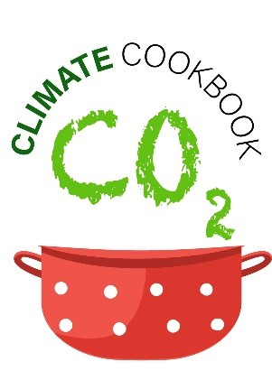
The Climate Cookbook project will research the level of knowledge in the gastronomy sector in Croatia and Slovenia related to the impact of the sector's operations on climate change. On the basis of the collected research results, an educational programme on climate change will be created following the activities in the gastro sector to reduce CO2 emissions. Also, a methodology will be developed and CO2 emissions calculated for about twenty traditional dishes in Croatia and Slovenia, and recipes with significant CO2 emissions during their production will be combined into a Climate Cookbook.

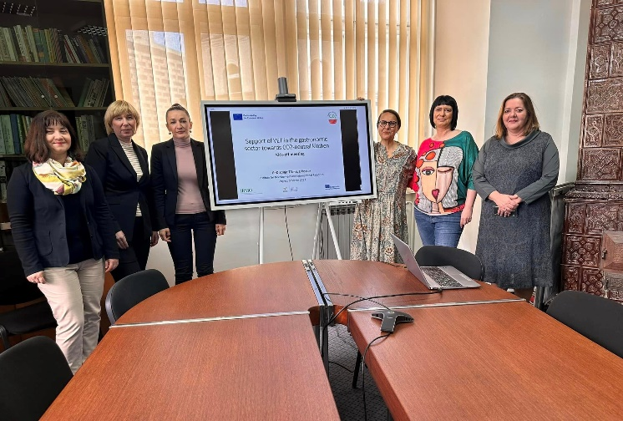
Information about climate change through the activities of the gastro sector as well as the Climate Cookbook will be presented to the general public, thus ensuring the popularization of scientific research at IRMO.

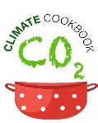

PROJECT OBJECTIVES

The main objective of the project is to develop and implement the new VET educational program for students and teachers on climate change and green topics in gastro sector and to raise public awareness through the preparation and consumption of appropriate meals.

TARGET GROUPS

Students of vocational schools
- Catering and gastronomic sector employees
- Teachers and lecturers in VET vocational schools of gastronomic orientation
- Interested public

ADDITIONAL FACTS

Program: Erasmus+ 2022-2-HR01-KA210-VET-000094467
Project duration: 1.01.2023 - 1.01.2025
Funding: Erasmus+ (KA210-VET) Small-Scale Partnership in Vocational Education and Training
Project partners:
Institute for Development and International Relations (IRMO), Croatia – Project coordinator
Rogaška Slatina People's University (LURS), Slovenia – Project partner
Project Leader: Sanja Tišma, PhD

1st TRANSNATIONAL MEETING IN ZAGREB, CROATIA

The first transnational project meeting
Was held in Zagreb, Croatia, on 8th March
2023.

Project partners, IRMO from Croatia and
LURS from Slovenia, met to discuss the
detailed plan of the project, quality
assurance of the project, dissemination
and other details in connection to the
project timeline, activities and outcomes.

Information about the
Project

http://climatecookbook.eu/
CLIMATE COOKBOOK FACEBOOK
CLIMATE COOKBOOK LINKEDIN
CLIMATE COOKBOOK INSTAGRAM

