UPDATES ABOUT THE PROJECT

September 2023 | Issue 2

Support of VET in gastronomic sector towards CO2 neutral kitchen - Climate Cookbook

2022-2-HR01-KA210-VET-000094467

Project partners have been very active for the last 6 months. Not only we have been working really hard on the deliver of the final outputs, but we have been presenting our project in Croatia and Slovenia.

Questionnaires for assessment of the knowledge and skills of students and teachers in vocational education and employees in the gastronomy and hospitality sector, which are related to the circular economy, climate change and CO2 emissions that occur during their work have been developed and disseminated to students, teachers and employees in the gastronomy and hospitality sector.
The results of the research have been analyzed and will be used to create an educational program in the field of gastronomy, for students and teachers of vocational schools and for participants of adult education programs.
You can check out the analysis of the questionnaires here

DISSEMINATION

Partners have presented the project at several events:

- Beats&Bites (music&street food festival) in Zagreb
- Place Market in Zagreb, Croatia
- yearly conference for education in Croatia
- Kulinarik.si in Rogaška Slatina, Slovenia

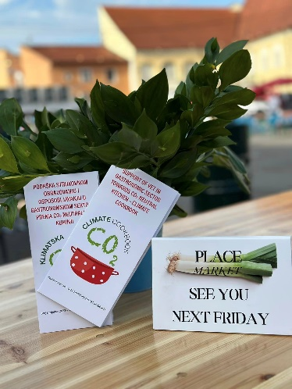

IMPORTANT DOCUMENTS

We have developed several important documents:

- Methodology for calculating the carbon footprint of food
- Report on the survey about the impact of food preparation on climate change and CO2 emissions in the gastro sector
- presentation Kruh naš svagdašnji i klimatske promjene

Check them out here.

Program: Erasmus+ 2022-2-HR01-KA210-VET-000094467
Project duration: 1.01.2023 - 1.01.2025
Funding: Erasmus+ (KA210-VET) Small-Scale Partnership in Vocational Education and Training
Project partners:
Institute for Development and International Relations (IRMO), Croatia – Project coordinator
Rogaška Slatina People's University (LURS), Slovenia – Project partner
Project Leader: Sanja Tišma, PhD

2nd TRANSNATIONAL MEETING IN ZAGREB, CROATIA

The second transnational project meeting
Was held in Zagreb, Croatia, on 2nd June
2023.

Representatives of IRMO from Croatia
and LURS from Slovenia discussed the
progress of the project; apart from
the overview of the Analysis of
research results about the impact of
food preparation on climate change
and carbon dioxide (CO2) emission
in gastronomy, an outline of the content
of the Climate Cookbook and
educational programme were discussed.

Information about the
Project

http://climatecookbook.eu/
CLIMATE COOKBOOK FACEBOOK
CLIMATE COOKBOOK LINKEDIN
CLIMATE COOKBOOK INSTAGRAM

